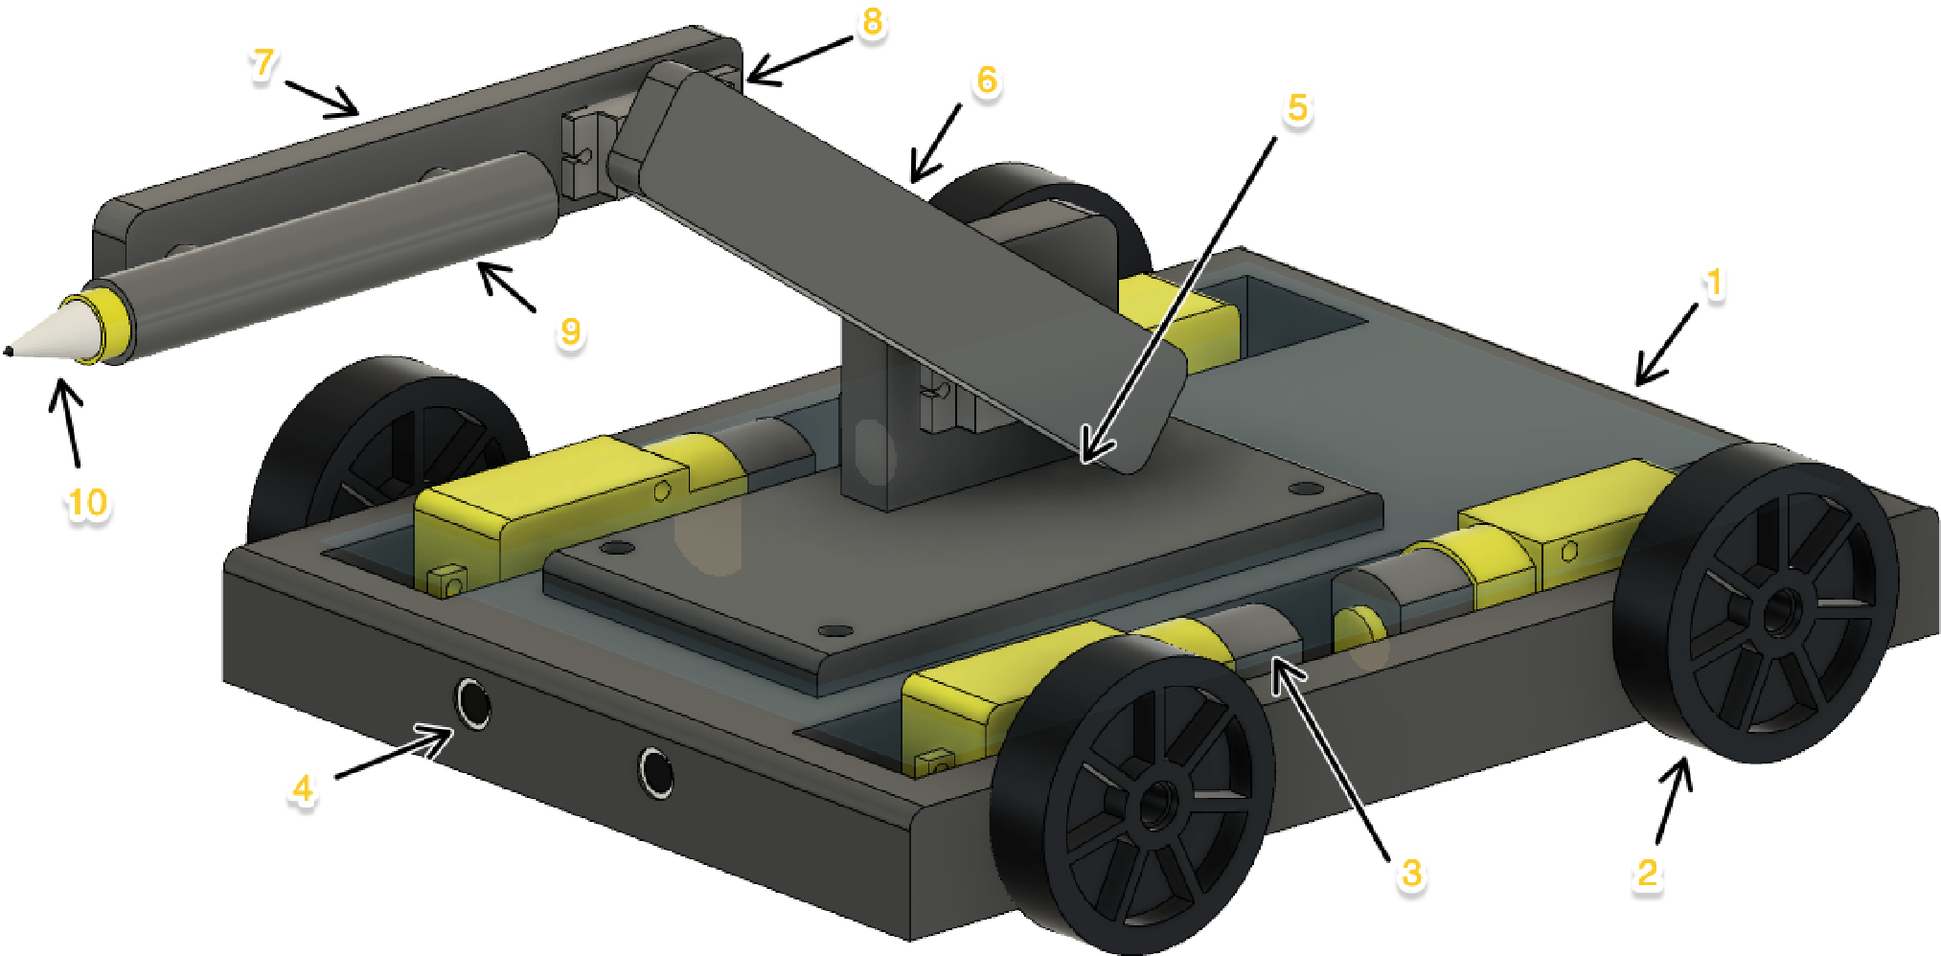
Tender Robot Design (TRDR)

Alexander King

Part

List

Item

Part

Name

1

Chassis

2

Wheels

3

Gear

Motors

4

Ultrasonic

Sensors

5

Robot

Arm

Base

6

Arm

1

7

Arm

2

8

Servo

Motors

9

Marker

pen

holder

10

Marker

pen

